DATE: October 14, 2020
Attention: Total Door Distributors and Sales Representatives
Regarding: 2021 Total Door Product Training Seminars

Hello,

We now have a schedule in place for the 2021 Product Information Seminars:

FEB 22 & 23 | AUG 23 & 24
MAR 23 – 25 (Sales/Install Combo) | SEPT 28 – 30 (Sales/Install Combo)
APR 26 & 27 | OCT 25 & 26
MAY 17 & 18 | NOV 16 – 18 (Sales/Install Combo)
JUN 21 & 22 | DEC 6 & 7
JUL 27 – 29 (Sales/Install Combo)

Installation / Service Seminars are Monday & Tuesday, 8am-5pm both days, with travel/hotel check-in on the Sunday before. Participants will leave certified.

Sales/Install Combo Seminars are Tuesday – Thursday (8am – 4:30pm) with travel/hotel check-in Monday before. Participants will leave certified.

Lunch will be provided for all attendees on seminar days, along with a dinner outing the evening of day one (and day two for the combination seminar). Also, hotel cost is on Total Door!

All attendees must register online

Dates are now available to register for on the Total Door website under the “Menu” side tab, then “Service and Support”, then “Training” (https://www.totaldoor.com/service-and-support/training/).
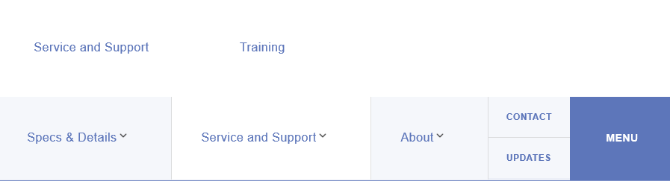

Please note that spots cannot be “held”; there is limited space for each class and attendance is on a first registered, first served basis.

Dates are subject to change.

Thank You,

Total Door Systems

